Tests to Diagnose the Cause of Infertility
The first step in diagnosing an issue relating to fertility is a comprehensive appointment with your doctor. During this appointment, your medical history and lifestyle will be discussed extensively. Topics such as birth control use, menstrual and pregnancy history, current and past sexual practices, medications used, surgical history, other health issues and what your lifestyle is like as well as your work/living environment will all be discussed.
A thorough physical exam will also be done. Areas such as your thyroid, breasts, and hair growth will be looked at. A pelvic exam is also an important part of evaluating fertility, along with a pap smear.
After this first appointment, your doctor may want to proceed with some initial tests. These tests will evaluate things such as if ovulation is occurring, when it should be occurring, ovarian function, and uterine function during the ovulation process. Usually one of the first questions regarding female fertility is whether you are ovulating or not.¹

Ovulation evaluation may be broken down into following types: ¹

- Ovulation testing– to confirm if ovulation is occurring by looking through your temperature charts, using ovulation predictor kits, blood tests and ultrasound.
- Ovarian function tests–These tests are looking to see how the hormones are functioning and working during your ovulation cycle. Tests include checking for various hormones such as Day 3 FSH (measuring follicle stimulating hormone), Day 3 Estradiol (measuring estrogen), ultrasound (to confirm ovulation occurred) and blood tests to determine the levels of Inhibin B.
- Luteal Phase testing- Tests will evaluate progesterone levels, more extensive hormone tests, and possibly an endometrial biopsy.

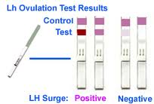

Ultrasound scan ²

An ultrasound scan checks the lining of your womb (endometrium) and diagnoses any conditions that may be distorting the lining.

It allows the doctor to check:

- If you have any fibroids or polyps, which could affect your cycle
- If you have any ovarian cysts
- How easy it will be to collect your eggs from the ovaries
- The size of your ovaries and if there are many small follicles.

It also gives a baseline report to compare with, later in your treatment.
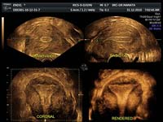

Checking your fallopian tubes and uterus ²

Additional tests may be needed to check your tubes are open (tubal patency), and the condition of your uterus and ovaries:
- Sonohysterogram - a relatively non-invasive test, which involves an ultrasound and insertion of a tiny tube into the cervix (neck of womb) to pass dye through the uterine cavity and tubes.

- Hysterosalpingogram - using X-rays to confirm the fallopian tubes are open (this does not provide any information about the ovaries and provides only limited information about the uterus).

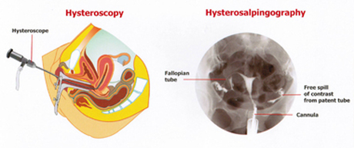

Male Infertility Testing

Semen analysis is the most important male infertility test, providing an accurate measurement of the number of sperm, motility (proportion of sperm that can swim) and morphology (sperm shape).³

References

- http://americanpregnancy.org/infertility/femalefertilitytesting.html
- http://ivf.com.au/fertility-treatment/female-infertility-tests
- http://mivf.com.au/fertility-treatment/male-infertility-tests

