Infertility Treatment
Infertility can be treated with medicine, surgery, artificial insemination, or assisted reproductive technology. Many times these treatments are combined.

Ovulation Induction

Ovulation Induction is a simple process which stimulates your ovaries to release eggs, so you maximize your chance of conception through intercourse or artificial insemination. It suits women who are producing low levels of hormones for ovulation, or who are not ovulating at all. You’ll take medication (as tablets or through injections) to stimulate your hormones.

How does Ovulation Induction work?

First, doctor will confirm your ovulation cycle by:
- Taking blood samples to measure hormone levels at specific stages of your cycle,
- Carrying out a transvaginal ultrasound to see the development of follicles in the ovaries, and the thickness and appearance of the lining of the womb.

The Ovulation Induction cycle

Day 1: (of your menstrual cycle) Call the clinic to arrange an appointment for a blood test.
Day 4: Start taking medication.
Day 10 or 11: Visit the clinic for a blood test to determine your hormone level.
Day 14: Attend the clinic for an ultrasound test. This will determine if you are about to ovulate.

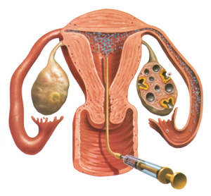
For women who don't have a normal menstrual cycle, it may take some time to ovulate. In fact, it is not unusual for ovulation to occur much later in their cycle (after Day 14). You would then need to continue attending the clinic for blood tests until this point.¹

Intrauterine Insemination (IUI)/Artificial Insemination

Intrauterine Insemination (IUI), is sometimes recommended as a simpler and more affordable starting point for fertility treatment. If you undergo more than three unsuccessful IUI attempts, it is usually recommended to start a more complex IVF treatment.
If you or your partner has been diagnosed with unexplained infertility, hostile cervical mucus, minor sperm abnormalities or other male disorders, IUI is sometimes a successful option. It can also be used when semen has been frozen due to a husband's absence or before chemotherapy or radiotherapy.

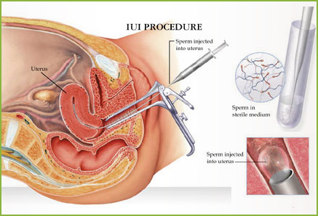

What does artificial insemination (IUI) involve?
Intrauterine insemination (IUI) involves inserting the male partner’s (or donor’s) prepared semen through the neck of the womb (cervix) and into the uterus, close to the time of ovulation. This procedure is performed by doctor and is usually not painful, although sometimes you might feel mild cramps and/or discomfort. You should be able to return to work/home straight away.

This procedure can be performed during a natural cycle or with artificial hormone stimulation (ovulation induction).²

Assisted Reproductive Technology (ART)

In Vitro Fertilization (IVF)

In Vitro Fertilization (IVF) can be used to overcome a range of fertility issues, including sperm antibodies, endometriosis, and unexplained infertility. For many couples, it gives them the best chance of having a baby.

How does IVF work?

With the IVF process, sperm fertilize the egg in a laboratory, rather than inside the woman's fallopian tubes.
An egg from the female partner is placed together in a culture dish with many thousands of sperm prepared from a semen sample provided by the male partner. Over the next few hours, fertilization takes place and a number of embryos are formed.

The fertilized embryos are developed in the laboratory over a period of two to five days, then transferred to the woman’s uterus in a simple procedure called an embryo transfer. ³

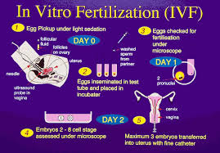

Intra Cystoplasmic Sperm Injection (ICSI)

If you are diagnosed with male fertility problems, such as a low sperm count or sperm that are unable to penetrate the egg, conventional IVF is unlikely to result in fertilization.
This is when Intracytoplasmic Sperm Injection (ICSI) is recommended. ICSI can also be used if the male partner has previously had a vasectomy. It is part of your IVF cycle, and the main difference is the technique used to achieve fertilization.

How does ICSI work?
A single sperm is injected into each egg, using very fine micro-manipulation equipment. As the human egg is one tenth of a millimetre in diameter and the sperm 100 times smaller, this is a very delicate procedure performed by highly skilled embryologists under a microscope.
This technique can also be used when sperm are not present in the semen, and have to be obtained surgically from the male reproductive tract.

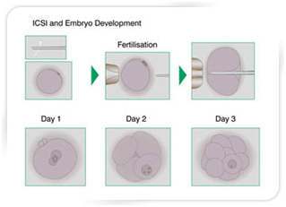

Is ICSI successful?
Together with IVF, ICSI is one of the most common techniques used in Assisted Reproductive Technology. Since it was introduced, it has led to the birth of many thousands of babies worldwide.⁴

References

- http://ivf.com.au/fertility-treatment/ovulation-induction-oi
- http://ivf.com.au/fertility-treatment/artificial-insemination-iui
- http://ivf.com.au/fertility-treatment/ivf-treatment
- http://ivf.com.au/fertility-treatment/icsi-treatment

