Understanding Menstrual Cycle

What is a menstrual cycle?

- The menstrual cycle is the series of changes a woman's body goes through to prepare for a pregnancy.
- About once a month, the uterus grows a new lining (endometrium) to get ready for a fertilized egg.
- When there is no fertilized egg to start a pregnancy, the uterus sheds its lining. This is the monthly menstrual bleeding (also called menstrual period) that women have from their early teen years until menopause, around age 50.
- The menstrual cycle is from Day 1 of bleeding to Day 1 of the next time of bleeding.
- Although the average cycle is 28 days, it is normal to have a cycle that is shorter or longer.¹

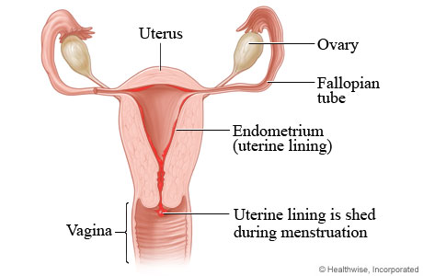

When does menstruation begin?

- On average, menarche (a young woman's first menstrual period) occurs between the ages of 12 and 14 years old—generally two years after her breast budding (average age 10 to 12 years old), and, in most cases, not long after the onset of pubic hair (average age 12 years old) and underarm hair.
- Stress, various types of strenuous exercise, and diet can affect the onset of menstruation and the regularity of the menstrual cycle.²

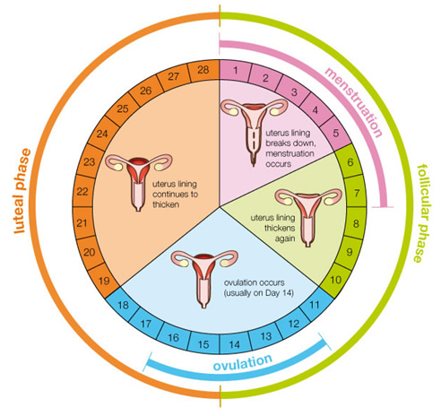

What controls the menstrual cycle?

- Your hormones control your menstrual cycle.
- During each cycle, your brain’s hypothalamus and pituitary gland send hormone signals back and forth with your ovaries.
- These signals get the ovaries and uterus ready for a pregnancy.
- The hormones estrogen and progesterone play the biggest roles in how the uterus changes during each cycle.
- A change in hormone levels can affect your cycle or fertility. This is also true for women nearing menopause.
- Teens and women in their 40s may have heavy menstrual bleeding and cycles that may change in length. ¹

How long is a menstrual cycle?

- For menstruating women, an average menstrual cycle lasts 28 days—starting with the first day of the last period (Onset of bleeding) and ending with the first day of the next menstrual period.

- On average, lasts six days, with some women having a very light flow and others having a very heavy flow

- The length of women's cycles varies, particularly for the first one to two years after menarche (first menstrual period).

- Women may have cycles as short as 23 days, or as long as 35 days. ²

References

- http://dubuqueinternalmed.com/patient-education/hw-view.php?DOCHWID=tn9930
- http://healthsource.baylorhealth.com/Library/Encyclopedia/85,P00553

