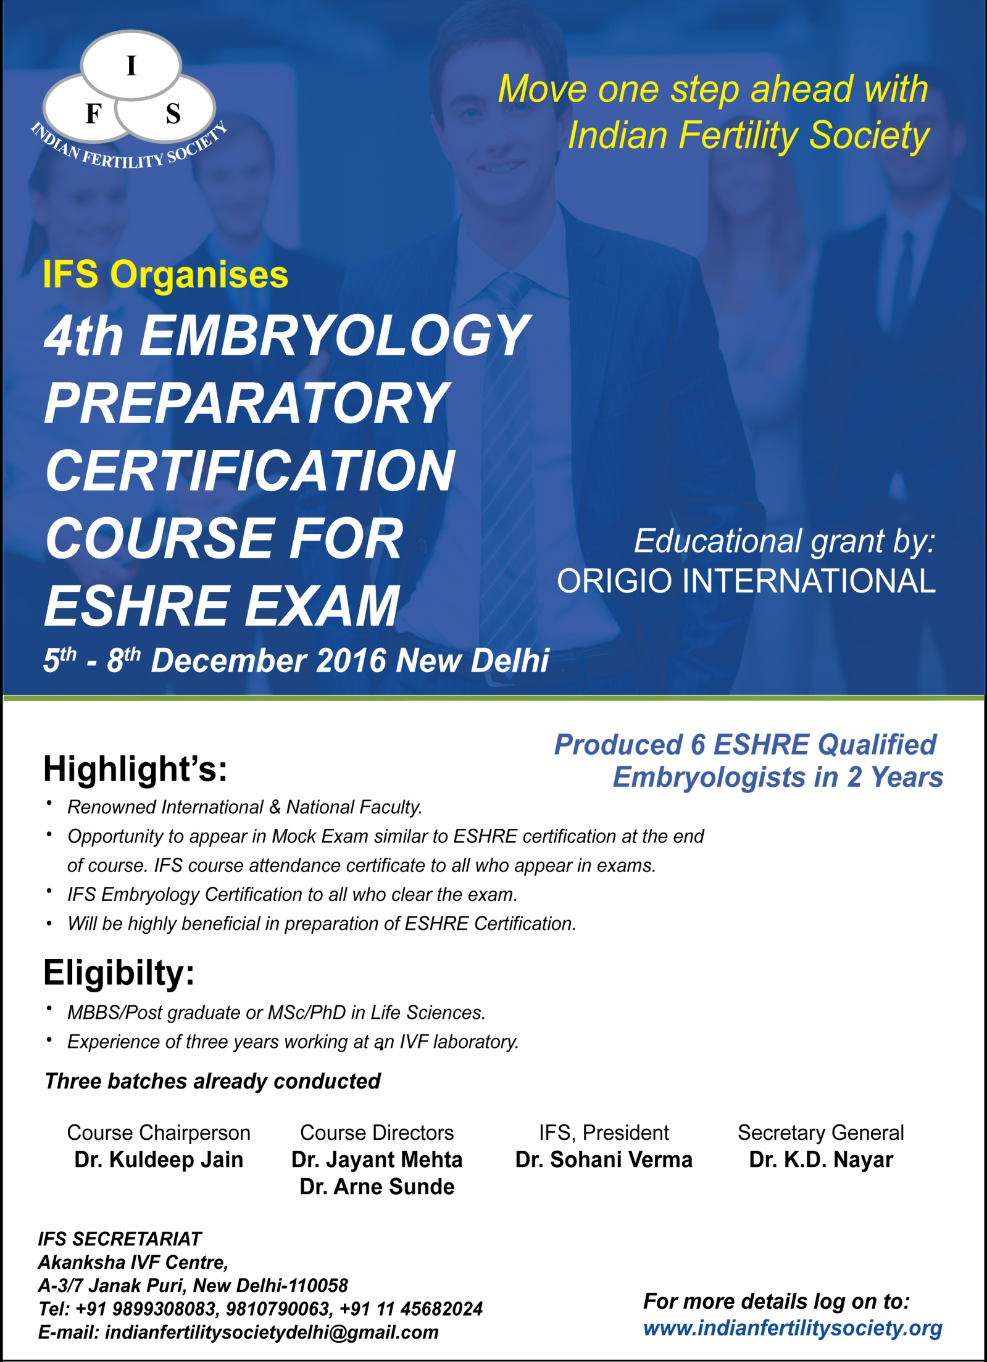

Indian Fertility Society

4th Embryology Preparatory Certification Course for ESHRE Exam,
5th – 8th December, New Delhi.

Requirements
To apply for the Clinical Embryologist certification, applicants must:
- Be an IFS member, for more information on IFS membership you can log on to www.indianfertilitysociety.org
- Holds B.Sc / M.Sc / M.B.B.S / M.D (Obst. & Gyane.)
- Have at least three years' hands-on experience in a clinical ART lab
- Submit a log book (please see logbook requirements)
- Pass an MCQ exam to achieve IFS Embryology Certification.

Log Book of practical experience
When filling out the application form you also have to show that you have performed a minimum number of treatments during your years in the laboratory
Minimum number of cases for application as Embryologist:
Method
Oocyte pick up | 50
Semen analysis | 50
Semen preparation | 50
IVF Insemination | 50
ICSI | 50
Zygote and embryo evaluation | 50
Embryo Transfers | 50
Cryopreservation of oocytes/embryos | 50
Thawing/warming of oocytes/embryos | 50
Please note that ALL methods need to be included in your logbook.

Example of how to fill in the logbook
If the procedure is still ongoing, don’t fill out a date but please write “still ongoing” on your printed logbook.
Type of Procedure | No. of cycles in clinic  < 12 months | No. of own cycles in clinic  < 12 months | No. of own cycles  in clinic in  total | Start date | Stop date | Signature  applicant | Signature  supervisor
Oocyte pick up | 350 | 59 | 536 | January 1998 | Still ongoing
Cryopreservation | 0 | 0 | 400 | May 1996 | December 2005
ICSI | 63 | 50 | 220 | August 2004 | Still ongoing
Please note that you do not have to fill every single case, but only the total number of cycles/cases of each method that you have performed during the period.
- Candidates appearing for IFS certification must submit the log book along with completely filled registration form by 15th November 2016 at the IFS Secretariat.

